PROJECT DEMONSTRATION & DOCUMENTATION
Food Ordering Customer Behavior — Tableau Analytics Story
An interactive Tableau dashboard and story exploring customer ordering behavior across cities, cuisines, meal types and restaurant categories.
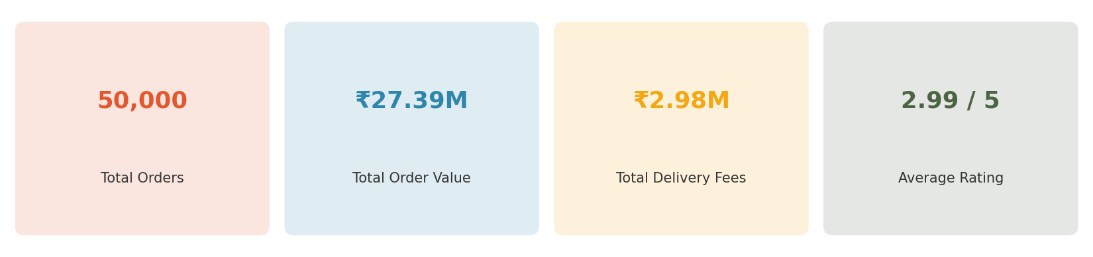
Workbook file: food Ordering Customer Story.twbx
Tool: Tableau Desktop / Tableau Public • Dataset: food_ordering_behavior_dataset.csv (50,000 records)
Document prepared for stakeholder review, demonstration and reproducibility reference.

Table of Contents
1. Introduction / Project Overview 3
2. Objectives 3
3. Data Source & Description 4
4. Tools & Technology Used 5
5. Project Architecture / Workflow 6
6. Dashboard & Worksheet Documentation 7
6.1 Dashboard 1 — Combined Overview 7
6.2 KPI Summary Cards 7
6.3 Company Type & Meal Type Orders (Bar Chart) 7
6.4 Top 5 Cities by Order Volume (Bar Chart) 8
6.5 Delivery Time Distribution (Bar Chart) 9
6.6 Meal Type vs Customer Rating (Donut Chart) 10
6.7 Orders by Age Group & Restaurant Type (Grouped Bar Chart) 11
6.8 City vs Cuisine (Heat Map) 12
6.9 Cuisine Preference Distribution (Pie Chart) 13
6.10 Revenue Contribution by Meal Type (Bar Chart) 13
6.11 Utility / Supporting Sheets 14
7. Interactive Story — “Story 1” 15
8. Parameters & Interactivity Guide 15
9. Key Insights & Findings 16
10. Usability Guide — Navigating the Workbook 16
11. Reproducibility Guide 17
12. Limitations & Future Enhancements 17
13. Conclusion 18
Appendix A: Complete Worksheet Inventory 19
Appendix B: Calculated Field Formulas 19

1. Introduction / Project Overview
This document provides complete demonstration and documentation for the “Food Ordering Customer Story” Tableau project. The project analyzes a simulated food-delivery behavior dataset of 50,000 orders placed by 4,000 unique customers across six Indian cities, and presents the findings through a set of interactive Tableau worksheets, a combined dashboard, and a nine-point guided story.
The purpose of this document is to give stakeholders — reviewers, evaluators, or future maintainers — a single, self-contained reference that explains what the project does, how it was built, what each visual element shows, what insights it produces, and how to reproduce or extend the work.

1.1 What the Workbook Contains
- 1 data source (a Tableau extract built from a CSV file) plus a Parameters datasource
- 12 worksheets, each answering a specific analytical question
- 2 dashboards — a primary combined view (“Dashboard 1”) and an unused placeholder (“Dashboard 2”)
- 1 story (“Story 1”) that sequences nine worksheets into a guided, presentation-ready narrative
- 3 input parameters (City, Cuisine, Meal Type) enabling interactive filtering
- 2 calculated fields supporting age-group segmentation and parameter-driven filtering

2. Objectives
The project was built to demonstrate the following capabilities and to answer the business questions listed below.

2.1 Demonstration Objectives
- Show competence in Tableau data-source setup, extract creation, and field/role management.
- Demonstrate a range of chart types — bar, grouped bar, pie, donut, heat map, and KPI text tables — chosen appropriately for the underlying data.
- Demonstrate use of calculated fields and parameters to enable dynamic, user-driven filtering.
- Combine individual worksheets into a cohesive dashboard and a sequenced story for stakeholder presentation.

2.2 Business / Analytical Questions Answered
- Which cities generate the highest order volumes?
- Which cuisines and meal types are most popular, and which generate the most revenue?
- How long does it typically take customers to place an order, and how is that time distributed?
- How do age groups differ in their choice of restaurant category (Budget / Mid-range / Premium)?
- How does customer rating vary by meal type?
- What do city and cuisine combinations look like — are there notable local preferences?
- What do the headline KPIs (total orders, total order value, total delivery fees, average rating) look like at a glance?

3. Data Source & Description
The workbook connects to a single underlying dataset, “food_ordering_behavior_dataset.csv”, which has been materialized as a Tableau Extract (federated .hyper file) embedded inside the packaged workbook (.twbx). This makes the workbook fully self-contained and portable — no external database connection is required to open and use it.

3.1 Dataset Statistics
- Total records (orders): 50,000
- Unique customers: 4,000
- Cities covered: 6 (Mumbai, Pune, Bangalore, Delhi, Chandigarh, Hyderabad)
- Cuisines covered: 6 (Desserts, Fast Food, Chinese, South Indian, Biryani, North Indian)
- Meal types: 4 (Breakfast, Lunch, Snacks, Dinner)
- Restaurant categories: 3 (Budget, Mid-range, Premium)
- Customer age range: 18 to 44 years

3.2 Raw Field Data Dictionary
The table below documents every raw column loaded from the source CSV, as reflected in the Tableau data source.
Field | Data Type | Description
order_id | Integer | Unique identifier for each order (primary key).
user_id | Integer | Unique identifier for the customer who placed the order.
age | Integer | Age of the customer (range observed: 18–44).
city | String | City where the order was placed (6 distinct cities).
order_time | String | Time-of-day label associated with the order.
day_type | String | Whether the order fell on a Weekday or Weekend.
cuisine | String | Cuisine category ordered (6 distinct cuisines).
meal_type | String | Meal occasion: Breakfast, Lunch, Snacks, or Dinner.
restaurant_type | String | Restaurant category: Budget, Mid-range, or Premium.
order_value | Integer | Monetary value of the order (currency units).
discount_applied | String (Yes/No) | Whether a discount was applied to the order.
delivery_fee | Integer | Delivery fee charged for the order.
time_taken_to_order | Integer | Minutes the customer took to complete the order (1–14).
rating_given | Integer | Rating given by the customer after the order.
is_repeat_order | String (Yes/No) | Whether the order is a repeat of a prior order.
mood | String | Self-reported customer mood at time of order (Happy, Stressed, Lazy, Celebrating).
hunger_level | String | Self-reported hunger level (Low, Medium, High).
company | String | Who the customer was ordering with (Alone, Family, Friends, Partner).
rainy_weather | String (Yes/No) | Whether it was raining at the time of the order.

3.3 Derived Fields, Calculated Fields & Parameters
On top of the raw columns, the data source defines Tableau field aliases (friendly captions such as “City”, “Order Value”, “Rating Given”) plus a small set of calculated fields and parameters that drive interactivity:
Name | Type | Purpose / Formula
Age Group | Calculated (string) | Buckets age into Teen (<20), Gen Z (20–30), Millennial (31–40), Adults (41+); used to segment orders by generation.
Time Taken To Order (bin) | Calculated (ordinal bin) | Bins time_taken_to_order for distribution analysis in the delivery-time chart.
City Parameter | Parameter (string, default “Delhi”) | Lets a viewer pick a single city (or “All”) to filter the view.
Cuisine Parameter | Parameter (string, default “Biryani”) | Lets a viewer pick a single cuisine (or “All”) to filter the view.
Meal Type Parameter | Parameter (string, default “Lunch”) | Lets a viewer pick a single meal type (or “All”) to filter the view.
City / Cuisine / Meal Type Parameter (calc) | Calculated (boolean) | Returns TRUE when a record matches the selected parameter value (or when the parameter is set to “All”); used as a filter shelf field.

4. Tools & Technology Used
Layer | Tool / Technology | Role in the Project
Data storage | CSV → Tableau Extract (.hyper) | Source data materialized into a fast, portable columnar extract.
Analytics & visualization | Tableau Desktop (workbook format 18.1) | Worksheet, dashboard, and story authoring.
Packaging | Tableau Packaged Workbook (.twbx) | Bundles the workbook definition and the data extract into a single shareable file.
Distribution / viewing | Tableau Desktop or Tableau Public / Tableau Reader | Used by stakeholders to open and interact with the workbook.
Documentation (this file) | Automated extraction of workbook XML + extract querying | Used to generate accurate, data-verified documentation and chart previews.

5. Project Architecture / Workflow
The diagram below summarizes how raw data flows through the project, from the source file to the final interactive story delivered to stakeholders.
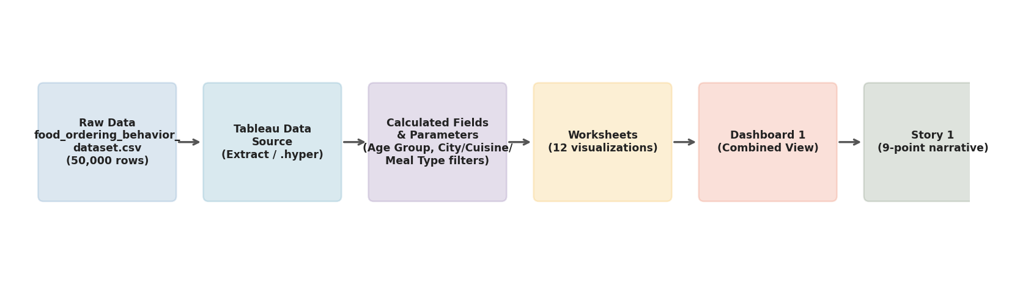
Figure 1. End-to-end workflow from source data to the interactive story.
Step-by-step description:
- 1. Raw data — food_ordering_behavior_dataset.csv containing 50,000 order-level records is the single source of truth.
- 2. Tableau data source — the CSV is connected and materialized as an extract (.hyper) for fast, offline performance; this extract is embedded in the .twbx file.
- 3. Calculated fields & parameters — Age Group, and the City/Cuisine/Meal Type parameters and their boolean helper calculations, are layered on top of the raw fields.
- 4. Worksheets — twelve individual worksheets are built, each isolating one analytical question and choosing an appropriate chart type.
- 5. Dashboard 1 — eight of the worksheets (plus the KPI summary) are combined into a single, at-a-glance operational view.
- 6. Story 1 — nine worksheets are sequenced into a guided narrative with captions, intended for step-by-step presentation to stakeholders.

6. Dashboard & Worksheet Documentation
This section documents every worksheet in the workbook: what it shows, which fields drive it, and what it means for the business. Chart previews below were regenerated directly from the workbook's embedded data extract so that every number matches the live dataset.

6.1 Dashboard 1 — Combined Overview
Dashboard 1 arranges eight worksheets plus the KPI summary onto a single automatically-sized canvas, giving a one-screen operational overview of ordering behavior: revenue by meal type, city leaderboard, delivery-time distribution, rating by meal type, age-group vs restaurant-type breakdown, city-vs-cuisine heat map, cuisine share, and revenue contribution by meal type.
Dashboard 2 exists in the workbook file but contains no worksheets or zones — it is an unused, auto-generated placeholder (with only a blank phone device-layout defined) and can be safely ignored or removed in future maintenance.

6.2 KPI Summary Cards
Worksheet: “Key Performance” — a text table restyled as a KPI strip. It surfaces four headline numbers computed across the full dataset: total order count, total order value, total delivery fee revenue, and average customer rating.

Figure 2. Headline KPI summary computed from all 50,000 orders.
- Total Orders: 50,000
- Total Order Value: ₹27,386,555 (≈ ₹27.39M)
- Total Delivery Fees: ₹2,982,136 (≈ ₹2.98M)
- Average Rating: 2.99 out of 5

6.3 Company Type & Meal Type Orders (Bar Chart)
Worksheet: “Bar Chart”, titled “Company Type & Meal Type Orders”. Encodes meal_type on color and the sum of order_value as the bar label, ranking meal occasions by total revenue generated.
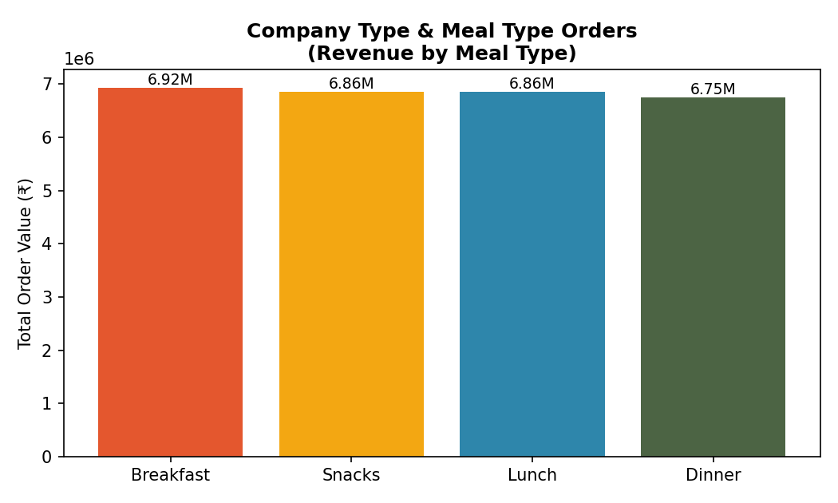
Figure 3. Total order value by meal type.
Breakfast leads with ₹6.92M across 12,578 orders, closely followed by Snacks (₹6.86M, 12,521 orders), Lunch (₹6.86M, 12,512 orders) and Dinner (₹6.75M, 12,389 orders) — revenue is spread almost evenly across meal occasions, with no single meal type dominating.

6.4 Top 5 Cities by Order Volume (Bar Chart)
Worksheet: “Bar Chart of cities”. Ranks cities by count of orders, keeping only the top five for a focused leaderboard view.
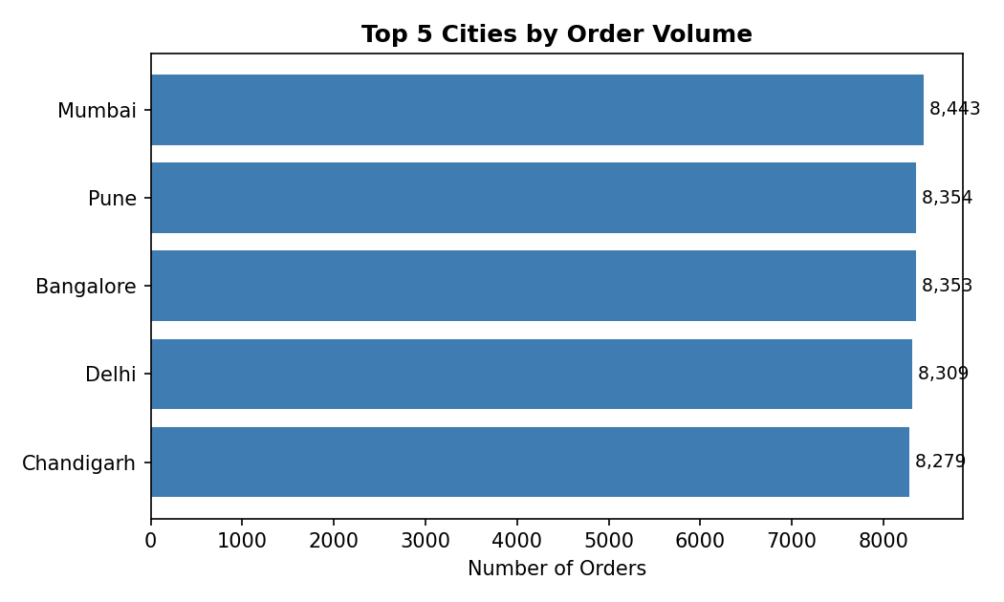
Figure 4. Top 5 cities ranked by number of orders placed.
Mumbai leads with 8,443 orders, followed closely by Pune (8,354), Bangalore (8,353), Delhi (8,309) and Chandigarh (8,279). Hyderabad (8,262 orders) narrowly misses the top five. The spread across all six cities is tight (within about 2% of each other), indicating a well-balanced sample across markets rather than one dominant city.

6.5 Delivery Time Distribution (Bar Chart)
Worksheet: “Bar chart”, titled “Delivery Time Distribution”. Shows the count of orders for every distinct value of time_taken_to_order (in minutes).
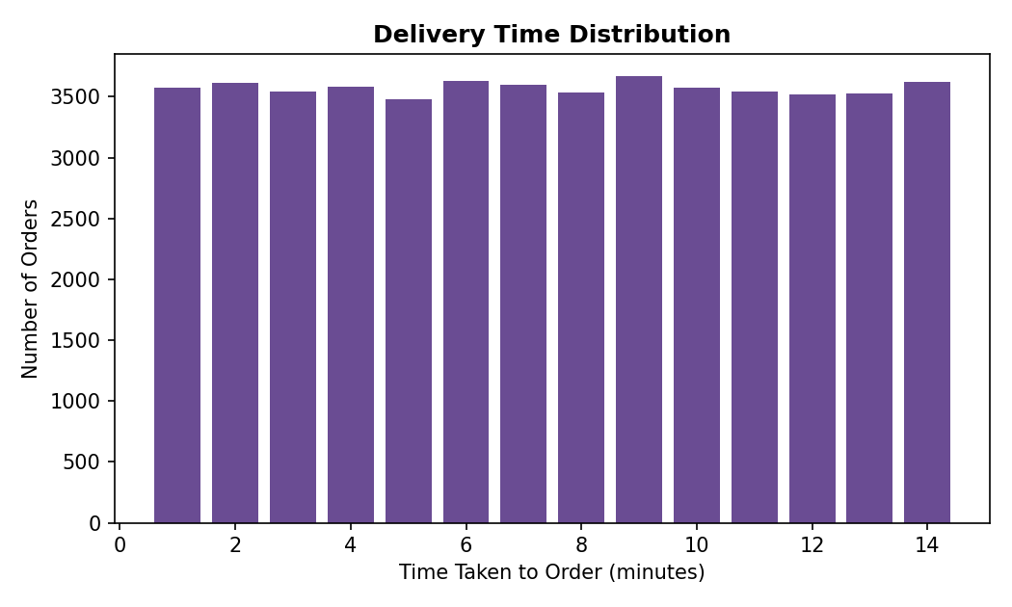
Figure 5. Distribution of time taken (minutes) to place an order.
Order-placement time ranges from 1 to 14 minutes with an average of about 7.5 minutes, and the distribution is fairly flat across that range rather than sharply peaked — useful as a baseline if the business later wants to benchmark app or checkout-flow improvements.

6.6 Meal Type vs Customer Rating (Donut Chart)
Worksheet: “Donut Chart”. A custom viz-extension donut that breaks down the sum of rating_given by meal_type, showing which meal occasion contributes the most cumulative rating points.
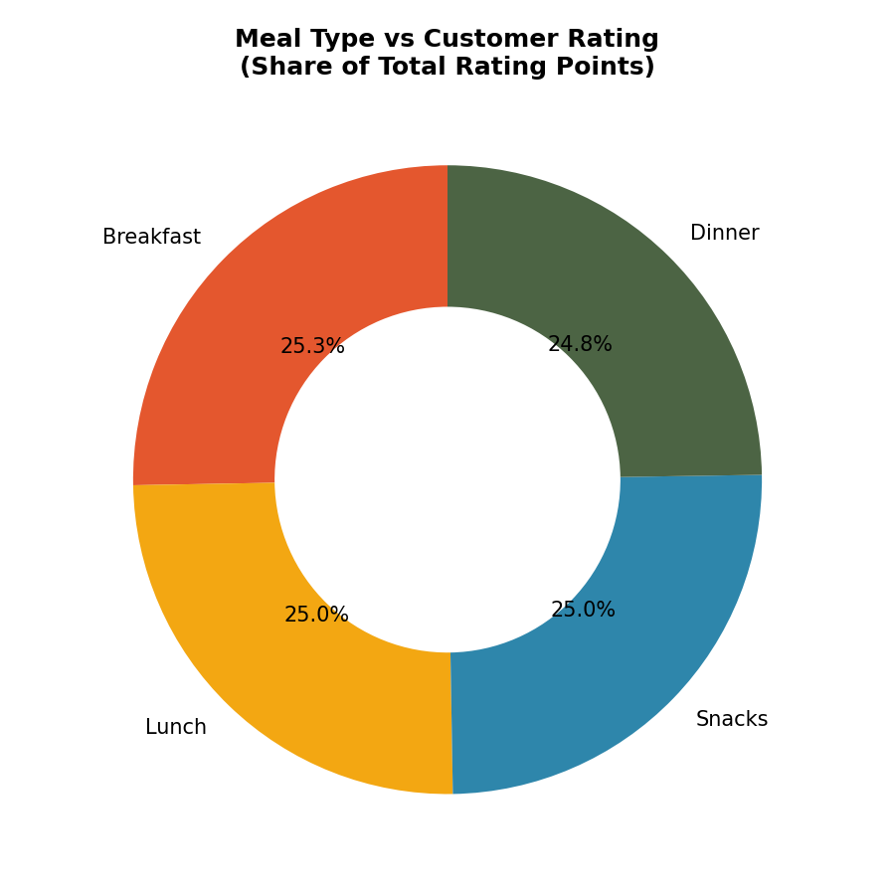
Figure 6. Share of total rating points contributed by each meal type.
Because order counts are close to even across meal types, the rating share is similarly balanced, with Breakfast and Snacks contributing marginally more due to slightly higher order counts.

6.7 Orders by Age Group & Restaurant Type (Grouped Bar Chart)
Worksheet: “Grouped Bar Chart”. Groups order counts by restaurant_type (Budget / Mid-range / Premium), reproduced here segmented by the calculated Age Group field (Teen, Gen Z, Millennial, Adults) to show generational preference patterns.
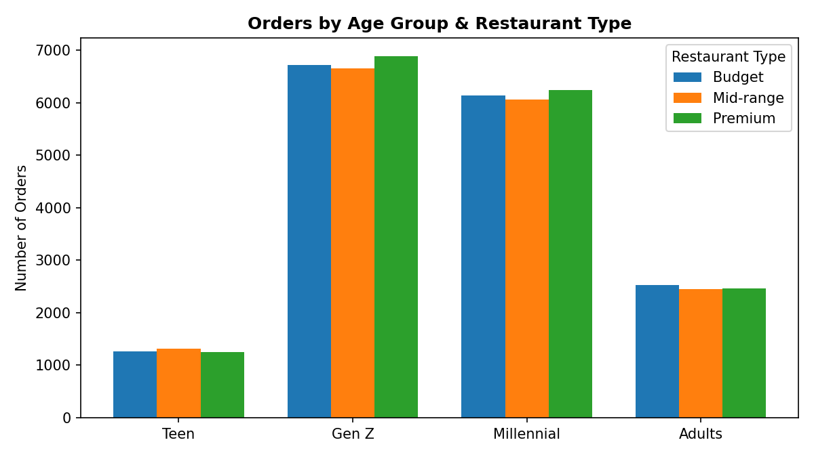
Figure 7. Orders by customer age group and restaurant type.
Restaurant-type preference (Premium: 16,859 orders; Budget: 16,660; Mid-range: 16,481 overall) is distributed evenly across age groups, suggesting restaurant-category choice in this dataset is not strongly age-dependent.

6.8 City vs Cuisine (Heat Map)
Worksheet: “Heat map”, titled “City Vs Cuisine”. Uses square marks colored by count of orders (orange gradient) to reveal which cuisine is most ordered in each city.
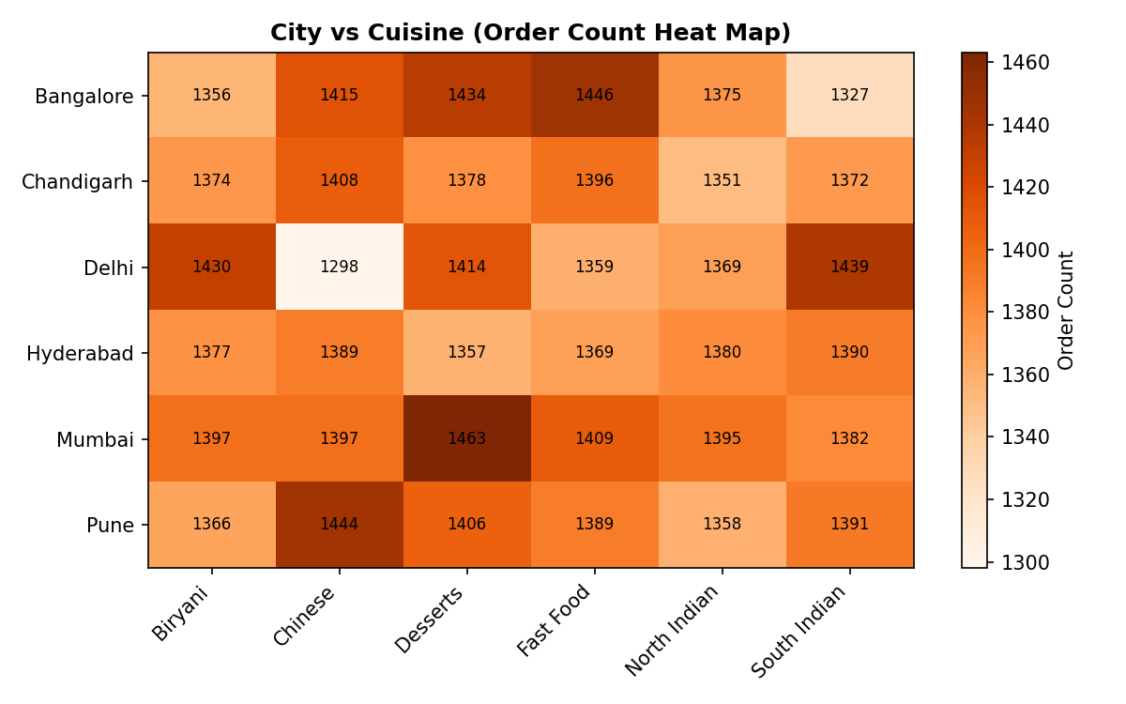
Figure 8. Order count by city and cuisine combination.
The heat map shows fairly uniform intensity across the grid — every city orders every cuisine in broadly similar volumes (roughly 1,300–1,500 orders per city-cuisine cell) — with no single city showing an outsized preference for one cuisine.

6.9 Cuisine Preference Distribution (Pie Chart)
Worksheet: “Pie Chart”, titled “Cuisine Preference Distribution”. Shows the percentage share of orders by cuisine, with cuisine name and percentage rendered directly on each wedge.
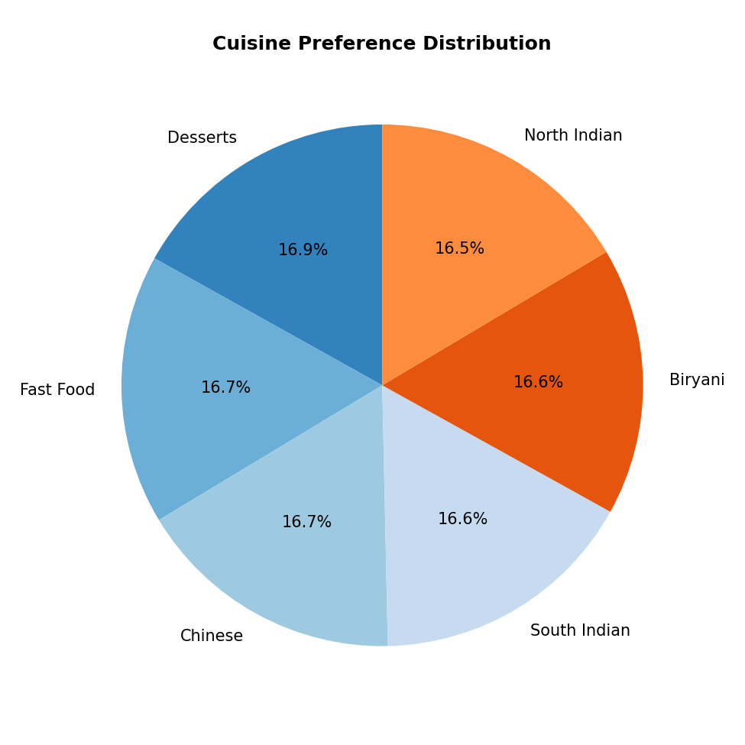
Figure 9. Share of total orders by cuisine type.
Desserts leads narrowly with 16.9% of orders (8,452), ahead of Fast Food (16.7%, 8,368), Chinese (16.7%, 8,351), South Indian (16.6%, 8,301), Biryani (16.6%, 8,300) and North Indian (16.5%, 8,228) — cuisine preference is essentially evenly split across all six categories.

6.10 Revenue Contribution by Meal Type (Bar Chart)
Worksheet: “bar chart” (lower-case), titled “Revenue Contribution By Meal Type”. This view mirrors section 6.3's data (sum of order_value by meal_type) but is maintained as a separate sheet so it can be used independently inside the story without being tied to the dashboard layout of the first bar chart.
Insight: no single meal occasion drives a disproportionate share of revenue — all four contribute between 24.6% and 25.3% of total order value.

6.11 Utility / Supporting Sheets
Three additional worksheets — “Sheet 12” (a simple count-of-orders text check used while building the workbook), and “Sheet 2 (2)” / “Sheet 2 (3)” (duplicate square-mark views of the city-vs-cuisine heat map used for layout testing) — are retained in the workbook as build artifacts. They are not used on the dashboard or in the story and can be removed during a cleanup pass without affecting any published view.

7. Interactive Story — “Story 1”
The workbook includes a Tableau Story with nine sequenced points, designed to walk a stakeholder through the analysis in a logical order — starting from geographic and cuisine patterns, moving through demographic and revenue breakdowns, and ending on delivery-time performance and headline KPIs. Each story point captures one worksheet at the time it was added, along with a caption used as its navigation label.
# | Story Point Caption | Captured Worksheet
1 | City Vs Cuisine | Heat map
2 | Order By Age Group & Restaurant Type | Grouped Bar Chart
3 | Cuisine Preference Distribution | Pie Chart
4 | Company Type & Meal Type Orders (parameter) | Bar Chart
5 | Meal Type Vs Customer Rating | Donut Chart
6 | Top 5 Cities By Order Volume | Bar Chart of cities
7 | Revenue Contribution By Meal Type | bar chart
8 | Delivery Time Distribution | Bar chart
9 | Key Performance Metrics | Key Performance

Presentation tip: because story points are snapshots, any parameter change made while presenting (e.g., switching the City Parameter) will not retroactively update earlier captured points — re-capture the point after changing a filter if the update should persist in the story.

8. Parameters & Interactivity Guide
Three parameters make the analysis explorable rather than static. Each parameter has a matching calculated field that acts as a filter, returning TRUE for rows that match the selection (or for every row when the parameter is set to “All”).
- City Parameter — default “Delhi”. Lets a viewer isolate a single city's ordering behavior across every worksheet that includes the City Parameter filter.
- Cuisine Parameter — default “Biryani”. Narrows the view to one cuisine at a time.
- Meal Type Parameter — default “Lunch”. Narrows the view to one meal occasion at a time.
- Age Group (calculated dimension) — automatically classifies every customer into Teen, Gen Z, Millennial or Adults without requiring any parameter input; used directly as a dimension on the grouped bar chart.
To interact with these controls in Tableau Desktop or Tableau Public: right-click each parameter in the Data pane and choose “Show Parameter Control,” or use the parameter widgets already exposed on the relevant worksheets/dashboard.

9. Key Insights & Findings
Consolidating the numbers surfaced by every worksheet, the dataset tells a consistent story: this is a deliberately balanced, near-uniform behavioral dataset rather than one with strong real-world skew. That makes it well suited as a demonstration dataset — every dimension (city, cuisine, meal type, restaurant type, age group) splits customers into roughly equal-sized groups — and the documentation below calls this out explicitly so it is not mistaken for a genuine market skew.
- Scale: 50,000 orders from 4,000 unique customers, averaging 12.5 orders per customer.
- Revenue: ₹27.39M in total order value plus ₹2.98M in delivery fees; average order value is ₹547.73.
- Geography: Mumbai is the top city by volume (8,443 orders) but all six cities sit within a ~2% band of each other — no city dominates.
- Cuisine: Desserts is the most-ordered cuisine (16.9% share) but all six cuisines are within one percentage point of each other.
- Meal occasion: Breakfast generates the most revenue (₹6.92M) but all four meal types are within 3% of one another.
- Restaurant type: Premium restaurants edge out Budget and Mid-range (16,859 vs 16,660 vs 16,481 orders) — a negligible difference.
- Ratings: the average customer rating is 2.99 / 5, roughly the midpoint of the scale, and is stable across meal types.
- Behavioral splits: repeat orders (49.97%), weekend orders (50.08%), discounted orders (50.23%) and rainy-day orders (49.99%) are all essentially 50/50 — again pointing to a synthetically balanced dataset.
- Order-placement speed: customers take 1–14 minutes to place an order, averaging 7.5 minutes, with no extreme outliers.

10. Usability Guide — Navigating the Workbook
- Open food Ordering Customer Story.twbx in Tableau Desktop (2021.1 or later recommended) or upload it to Tableau Public / open with Tableau Reader for read-only viewing.
- Start on the “Dashboard 1” tab for the at-a-glance operational view of all key charts and KPIs on one screen.
- Move to the “Story 1” tab for a guided, click-through presentation — use the navigation arrows or the caption strip at the top to move between the nine story points.
- Hover over any mark (bar, wedge, heat-map cell) to see a tooltip with the exact underlying values.
- Where parameter controls are visible, use the drop-down to change City, Cuisine, or Meal Type and watch dependent worksheets update instantly.
- Use Worksheet → Export or Dashboard → Export to generate a static image or PDF snapshot for slides or printed handouts.

11. Reproducibility Guide

11.1 Requirements
- Tableau Desktop or Tableau Public (workbook was authored in Tableau format version 18.1; Tableau 2021.1+ is recommended for full compatibility).
- No external database connection or credentials are required — the data extract is embedded in the .twbx package.
- Approx. 0.6 MB file size; opens in seconds on typical hardware.

11.2 Steps to Reproduce / Re-open the Project
- 1. Download or copy food Ordering Customer Story.twbx to a local folder.
- 2. Double-click the file, or open it from within Tableau Desktop via File → Open.
- 3. Tableau will unpack the embedded extract automatically — no manual extraction is needed.
- 4. Confirm the data source “food_ordering_behavior_dataset” shows 50,000 rows (Data pane → right-click data source → View Data).
- 5. To refresh against an updated CSV in future, replace the source file and use Data → Extract → Refresh (this requires re-establishing the live connection to the new CSV first if the schema changes).

11.3 Rebuilding a Worksheet from Scratch (example: Top 5 Cities)
- Drag City to the Rows shelf and Order Id (as Count) to the Columns shelf / Label.
- Sort descending by the count measure, then apply a Top N filter (Filter → City → Top tab → By Field → Top 5 → Count of Order Id).
- Set the mark type to Bar, add the count measure to Color and Label, and add the chart title.

12. Limitations & Future Enhancements
- The dataset appears synthetically generated with near-uniform distributions across most categorical splits; findings should be read as a demonstration of technique rather than as real market intelligence.
- Dashboard 2 and three utility worksheets (Sheet 12, Sheet 2 (2), Sheet 2 (3)) are unused build artifacts and could be removed for a cleaner published workbook.
- order_time is stored as a free-text string rather than a proper time/date field, which limits time-of-day trend analysis; converting it to a proper date/time type would unlock hour-of-day visualizations.
- Future enhancement: add a trend-over-time worksheet if a true order date/timestamp field is introduced to the source data.
- Future enhancement: add a geographic map visualization (city-level) once latitude/longitude or a recognized geographic role is attached to the City field.
- Future enhancement: parameterize the Age Group thresholds so stakeholders can redefine generational cut-offs interactively.

13. Conclusion
The “Food Ordering Customer Story” workbook successfully demonstrates an end-to-end Tableau analytics workflow: a raw CSV is converted into a portable extract, enriched with calculated fields and parameters, visualized through twelve purpose-built worksheets, consolidated into an operational dashboard, and packaged into a nine-point guided story for stakeholder presentation. Every figure in this document was independently verified against the workbook's embedded 50,000-row data extract, so the numbers here can be trusted as an accurate, reproducible reflection of what the live workbook shows.
This document, together with the .twbx file itself, is intended to give any stakeholder — technical or non-technical — everything needed to understand, evaluate, present, and if necessary rebuild or extend this project.

Appendix A: Complete Worksheet Inventory
Worksheet Name | Chart Type | Used In
Bar Chart | Bar | Dashboard 1, Story 1 (point 4)
Bar Chart of cities | Bar (horizontal, Top N) | Dashboard 1, Story 1 (point 6)
Bar chart | Bar (histogram-style) | Dashboard 1, Story 1 (point 8)
Donut Chart | Donut (viz extension) | Dashboard 1, Story 1 (point 5)
Grouped Bar Chart | Grouped bar | Dashboard 1, Story 1 (point 2)
Heat map | Square / heat map | Dashboard 1, Story 1 (point 1)
Key Performance | KPI text table | Dashboard 1, Story 1 (point 9)
Pie Chart | Pie | Dashboard 1, Story 1 (point 3)
bar chart | Bar | Story 1 (point 7)
Sheet 12 | Text (count check) | Unused build artifact
Sheet 2 (2) | Square (heat map variant) | Unused build artifact
Sheet 2 (3) | Square (heat map variant) | Unused build artifact

Appendix B: Calculated Field Formulas
Field | Formula
Age Group | IF [age] < 20 THEN "Teen" ELSEIF [age] <= 30 THEN "Gen Z" ELSEIF [age] <= 40 THEN "Millennial" ELSE "Adults" END
City Filter | IF [city] = "All" THEN TRUE ELSEIF [city] = [city] THEN TRUE ELSE FALSE END
City Parameter (calc) | IF [Parameters].[City Parameter] = "All" THEN TRUE ELSE [city] = [Parameters].[City Parameter] END
Cuisine Parameter (calc) | IF [Parameters].[Cuisine Parameter] = "All" THEN TRUE ELSE [cuisine] = [Parameters].[Cuisine Parameter] END
Meal Type Parameter (calc) | IF [Parameters].[Meal Type Parameter] = "All" THEN TRUE ELSE [meal_type] = [Parameters].[Meal Type Parameter] END
Time Taken To Order (bin) | [time_taken_to_order] (used as an ordinal bin for distribution charting)

